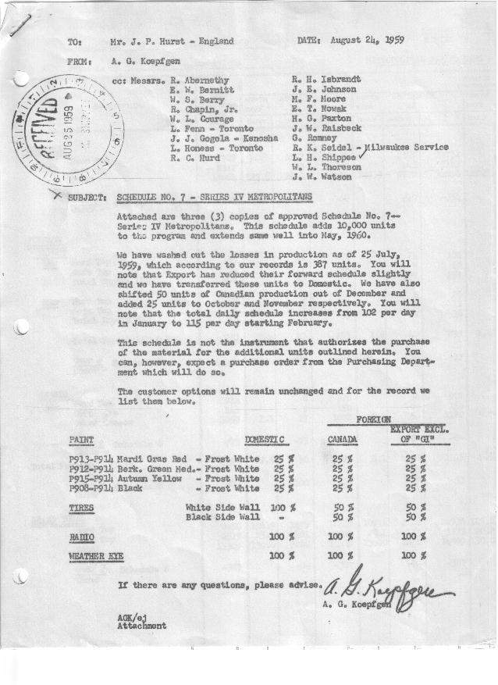

FORM AM 1262 Page 1 of 2 APPROVED R. Abernethy (signed) DATE 8-24-59

SCHEDULE NO. ______7 ___ DATE 8-24-59 MONTHLY BUILDING SCHEDULE APPROVED E.W.Bernitt (signed) DATE_ 8-24-59 _
REVISION NO. _______ __ ____ DATE PRODUCT APPROVED R. W.Chapin Jr. (signed) DATE _ 8-24-59 ____
SERIES IV 1500 c.c. ENGINE
METROPOLITAN SERIES CARS – AUSTIN MOTORS CO., LTD, ENGLAND
DESCRIPTION | BUILT  ◻ACT EST  THRU  July | FIRM BUILDING SCHEDULE  (FABRICATED MATERIAL RELEASE) |  |  |  |  |  |  |  |  |  |  |  |  |  |  | TENTATIVE SCHEDULE  (RAW MATERIAL RELEASED) |  |  | GRAND  TOTAL
DESCRIPTION | BUILT  ◻ACT EST  THRU  July | MONTH AUGUST  DAYS 16 |  |  | MONTH SEPTEMBER  DAYS 22 |  |  | MONTH OCTOBER  DAYS 22 |  |  | MONTH NOVEMBER  DAYS 21 |  |  | MONTH DECEMBER  DAYS 21 |  |  | MONTH JANUARY ‘60  DAYS 21 |  |  | GRAND  TOTAL
DESCRIPTION | BUILT  ◻ACT EST  THRU  July | DAILY | MONTH | CUM’L  TOTAL | DAILY | MONTH | CUM’L  TOTAL | DAILY | MONTH | CUM’L  TOTAL | DAILY | MONTH | CUM’L  TOTAL | DAILY | MONTH | CUM’L  TOTAL | DAILY | MONTH | CUM’L TOTAL | GRAND  TOTAL
DOMESTIC LHD:
Hard-Top | 7767 |  | 1657 | 9424 |  | 2327 | 11751 |  | 2264 | 14015 |  | 1663 | 15678 |  | 1726 | 17404 |  | 1452 | 18856
Soft-Top | 2317 |  | 383 | 2700 |  | 443 | 3143 |  | 431 | 3574 |  | 317 | 3891 |  | 329 | 4220 |  | 622 | 4842
Total U.S. | 10084 | 127.5 | 2040 | 12124 | 125.9 | 2770 | 14894 | 122.5 | 2695 | 17589 | 94.3 | 1980 | 19569 | 97.8 | 2055 | 21624 | 98.8 | 2074 | 23698
Over/(Under) Schedule 6 | (464) |  | 100 | (364) |  | 10 | (354) |  | (15) | (369) |  | (5) | (374) |  | 62 | (312) |  | 920 | 608
FOREIGN:
EXPORT LHD Hard-Top | 153 |  | 11 | 164 |  | 24 | 188 |  | 20 | 208 |  | 20 | 228 |  | 20 | 248 |  | 20 | 268
Soft-Top | 54 |  | 7 | 61 |  | 8 | 69 |  | 10 | 79 |  | 10 | 89 |  | 10 | 99 |  | 10 | 109
Total Export LHD | 207 |  | 18 | 225 |  | 32 | 257 |  | 30 | 287 |  | 30 | 317 |  | 30 | 347 |  | 30 | 377
RHD Hard Top | 16 |  | 3 | 19 |  | 6 | 25 |  | 7 | 32 |  | 7 | 39 |  | 7 | 46 |  | 7 | 53
Soft Top | 7 |  | 2 | 9 |  | 2 | 11 |  | 3 | 14 |  | 3 | 17 |  | 3 | 20 |  | 3 | 23
Total Export RHD | 23 | 1.4 | 5 | 28 | 1.8 | 8 | 36 | 1.8 | 10 | 46 | 1.9 | 10 | 56 | 1.9 | 10 | 66 | 1.9 | 10 | 76
Total Export LHD & RHD | 230 |  | 23 | 253 |  | 40 | 293 |  | 40 | 333 |  | 40 | 373 |  | 40 | 413 |  | 40 | 453
Over/(Under) Schedule 6 | 4 |  | (27) | (23) |  | (10) | (33) |  | (10) | (43) |  | (20) | (63) |  | (12) | (75) |  | 40 | (35)
CANADA Hard-Top | 914 |  | 8 | 922 |  | 50 | 972 |  | 125 | 1097 |  | 125 | 1222 |  | 50 | 1272 |  | 30 | 1302
Soft-Top | 141 |  | 9 | 150 |  | -0- | 150 |  | -0- | 150 |  | -0- | 150 |  | -0- | 150 |  | -0- | 150
Total Canada | 1055 | 1.1 | 17 | 1072 | 2.3 | 50 | 1122 | 5.7 | 125 | 1247 | 5.9 | 125 | 1372 | 2.4 | 50 | 1422 | 1.4 | 30 | 1452
Over/(Under) Schedule 6 | 73 |  | (73) | -0- |  | -0- | -0- |  | 25 | 25 |  | 25 | 50 |  | (50) | -0- |  | 30 | 30
Total Foreign | 1285 | 2.5 | 40 | 1325 | 4.1 | 90 | 1415 | 7.5 | 165 | 1580 | 7.8 | 165 | 1745 | 4.3 | 90 | 1835 | 3.3 | 70 | 1905
Over/(Under) Schedule 6 | 77 |  | (100) | (23) |  | (10) | (33) |  | 15 | (18) |  | 5 | (13) |  | (62) | (75) |  | 70 | (5)
GRAND TOTALS
Hard-Top | 8850 | 104.9 | 1679 | 10529 | 109.4 | 2407 | 12936 | 109.8 | 2416 | 15352 | 86.4 | 1815 | 17167 | 85.8 | 1803 | 18970 | 71.9 | 1509 | 20479
Soft-Top | 2519 | 25.1 | 401 | 2920 | 20.6 | 453 | 3373 | 20.2 | 444 | 3817 | 15.7 | 330 | 4147 | 16.3 | 342 | 4489 | 30.2 | 635 | 5124
Total | 11369 | 130.0 | 2080 | 13449 | 130.0 | 2860 | 16309 | 130.0 | 2860 | 19169 | 102.1 | 2145 | 21314 | 102.1 | 2145 | 23459 | 102.1 | 2144 | 25603
Over/(Under) Schedule 6 | (387) |  | -0- | (387) |  | -0- | (387) |  | -0- | (387) |  | -0- | (387) |  | -0- | (387) |  | 990 | 603

FORM AM 1262 Page 2 of 2 APPROVED R. Abernethy (signed) DATE 8-24-59

SCHEDULE NO. ______7 ___ DATE 8-25-49 (8-24-59)? MONTHLY BUILDING SCHEDULE APPROVED E.W.Bernitt (signed) DATE_ 8-24-59 _
REVISION NO. _______ __ ____ DATE PRODUCT APPROVED R. W.Chapin Jr. (signed) DATE _ 8-24-59 ____
SERIES IV 1500 c.c. ENGINE
METROPOLITAN SERIES CARS – AUSTIN MOTORS CO., LTD, ENGLAND
DESCRIPTION | BUILT  ◻ACT EST  THRU | FIRM BUILDING SCHEDULE  (FABRICATED MATERIAL RELEASE) |  |  |  |  |  |  |  |  |  |  |  |  |  |  | TENTATIVE SCHEDULE  (RAW MATERIAL RELEASED) |  |  | GRAND  TOTAL
DESCRIPTION | BUILT  ◻ACT EST  THRU | MONTH FEBRUARY 1960  DAYS 21 |  |  | MONTH MARCH 1960  DAYS 23 |  |  | MONTH APRIL 1960  DAYS 19 |  |  | MONTH MAY 1960  DAYS 18.7 (22 Available) |  |  | MONTH  DAYS |  |  | MONTH  DAYS |  |  | GRAND  TOTAL
DESCRIPTION | BUILT  ◻ACT EST  THRU | DAILY | MONTH | CUM’L  TOTAL | DAILY | MONTH | CUM’L  TOTAL | DAILY | MONTH | CUM’L  TOTAL | DAILY | MONTH | CUM’L  TOTAL | DAILY | MONTH | CUM’L  TOTAL | DAILY | MONTH | CUM’L TOTAL | GRAND  TOTAL
DOMESTIC LHD:
Hard-Top |  |  | 1642 | 20498 |  | 1659 | 22157 |  | 1462 | 23619 |  | 1468 | 25087
Soft-Top |  |  | 703 | 5545 |  | 711 | 6256 |  | 488 | 6744 |  | 489 | 7233
Total U.S. |  | 111.7 | 2345 | 26043 | 103.0 | 2370 | 28413 | 102.6 | 1950 | 30363 | 104.6 | 1957 | 32320
Over/(Under) Schedule 6 |  |  | 2345 | 2953 |  | 2370 | 5323 |  | 1950 | 7273 |  | 1957 | 9230
FOREIGN:
EXPORT LHD Hard-Top |  |  | 20 | 288 |  | 20 | 308 |  | 20 | 328 |  | 20 | 348
Soft-Top |  |  | 10 | 119 |  | 10 | 129 |  | 10 | 139 |  | 10 | 149
Total Export LHD |  |  | 30 | 407 |  | 30 | 437 |  | 30 | 467 |  | 30 | 497
RHD Hard Top |  |  | 7 | 60 |  | 7 | 67 |  | 7 | 74 |  | 7 | 81
Soft Top |  |  | 3 | 26 |  | 3 | 29 |  | 3 | 32 |  | 3 | 35
Total Export RHD |  |  | 10 | 86 |  | 10 | 96 |  | 10 | 106 |  | 10 | 116
Total Export LHD & RHD |  | 1.9 | 40 | 493 | 1.8 | 40 | 533 | 2.1 | 40 | 573 | 2.1 | 40 | 613
Over/(Under) Schedule 6 |  |  | 40 | 5 |  | 40 | 45 |  | 40 | 85 |  | 40 | 125
CANADA Hard-Top |  |  | 30 | 1332 |  | 170 | 1502 |  | 140 | 1642 |  | 110 | 1752
Soft-Top |  |  | -0- | 150 |  | 65 | 215 |  | 55 | 270 |  | 45 | 315
Total Canada |  | 1.4 | 30 | 1482 | 10.2 | 235 | 1717 | 10.3 | 195 | 1912 | 8.3 | 155 | 2067
Over/(Under) Schedule 6 |  |  | 30 | 60 |  | 235 | 295 |  | 195 | 490 |  | 155 | 645
Total Foreign |  | 3.3 | 70 | 1975 | 12.0 | 275 | 2250 | 12.4 | 235 | 2485 | 10.4 | 195 | 2680
Over/(Under) Schedule 6 |  |  | 70 | 65 |  | 275 | 340 |  | 235 | 575 |  | 195 | 770
GRAND TOTALS
Hard-Top |  | 80.9 | 1699 | 22178 | 80.7 | 1856 | 24034 | 85.7 | 1629 | 25663 | 85.8 | 1605 | 27268
Soft-Top |  | 34.1 | 716 | 5840 | 34.3 | 789 | 6629 | 29.3 | 556 | 7185 | 29.2 | 547 | 7732
Total |  | 115.0 | 2415 | 28018 | 115.0 | 2645 | 30663 | 115.0 | 2185 | 32848 | 115.0 | 2152 | 35000
Over/(Under) Schedule 6 |  |  | 2415 | 3018 |  | 2645 | 5663 |  | 2185 | 7848 |  | 2152 | 10000

